Bread Crumb

**Project**

**Software Requirement Specification**

Version 1.0

September 10, 2016

Prepared by:

Andrew Olson

**Contents**

**1 Introduction**

* 1. Purpose…………………………………………………………………………………………………………………...3
  2. Scope of the Project………………………………………………………………………………………………...3
  3. Definitions, Acronyms, and Abbreviations…………………………………..………………………..3-4
  4. References……………………………………………..…………………………………..…………………………...4
  5. Overview………………………………………………..…………………………………..…………………………...4

1. **Overall Description** 
   1. Product Perspectives…………………………………………………………………..…………………………...4
      1. User Interfaces…………….………………………………………..……………………………....4
      2. Software Interfaces…………….……….………………………..……………………………....4
      3. Communication interfaces……………………………………..……………………………....5
      4. Memory………………………………………………………………………………………………….5
      5. Operation……………………………………………………………………………………………….5
   2. Product Functions…………………………………………………………………………………………………….5
   3. User Characteristics…………………………………………………………………………………………….6
   4. Constraints………………………………………………………………………………………………………………6
      1. Operating Systems……….....…………………………………………………………………….6
      2. Connections…………………………………………………………………………………………6
      3. Platforms………………………………………………………………………………………………..6
      4. Content Creation…………………………………………………………………………………….6
      5. Accessibility…………………………………………………………………………………………….6
   5. Assumptions and Dependencies……………………………………………………………………………..6
2. **Specific Requirements**
   1. Performance Requirements………………………………………………………………………………………7
   2. Design Constraints……………………………………………………………………………………………………7
   3. Software system attributes……………………………………………………………………………………7
   4. Security Requirements……………………..……………………………………………………………………7

**1 Introduction**

* 1. **Purpose**

This software requirements specification is intended to provide a complete and working description of the mobile application “Bread Crumb”. It contains both an outlining of the software to be made as well as detailed, specific requirements. This document’s expected audience is any perspective venture capitalist interested in a new investment. This project started as an idea devised by Ernie Lara, after a visit to an Angels game. This will begin the first phase of the project. The first phase will be to get a working model started. The intended client is Ernie.

* 1. **Scope of the Project**

The software to be designed will be a mobile application for the use of the general public. This applications goal is to allow users to make notes on where they parked their car.

Specifically, the application will include a number of tools to assist users:

* The application will have a map in which the may place a marker on their current location and allow users to navigate back to their car.
* There will be a section where users may take notes.

For example: “Parked car in section A row 19.”

* A camera function will be enabled so that users may take photos of their surrounding areas.
* All Notes, locations, and images will be stored on the user’s device using core data.
  1. **Definitions, Acronyms, and Abbreviations**

**IOS:** is a mobile operating system created and developed by Apple Inc. and distributed exclusively for Apple Hardware.

**Xcode:** The Official IDE for IOS application development

**Client:** Ernie Lara

**DB:** Database

**GB:** Gigabyte

A unit of memory, equivalent to roughly 1 billion bytes.

**IDE:** Integrated Development Environment

**MB:** Megabyte

A unit of memory, equivalent to roughly 1 million bytes.

**RAM:** Random Access Memory

(A type of computer memory used for fast access during program usage)

**SDK:** Software Development Kit

An environment designed for the purpose of developing a specific type of application,

Containing tools and code libraries that facilitate development.

**TCP/IP:** Internet Protocol Suit

A standard networking protocol for end-to-end connectivity. Requires some overhead.

**Cache:** Data that is stored locally on the mobile device or in the server’s memory for the purpose of fast access.

* 1. **References**

IEEE Std. 830-1998 Software Requirement Specification

CSUSB Student Advising Mobile Application – SRS Version 2.2

UML Distilled Third Edition – A brief guide to the Standard Object Modeling Language

* 1. **Overview**

The rest of this document is organized into three sections, the second provides an overall description of the mobile application. This includes it’s interfaces, accessibility and usability requirements, user characteristics, constraints, and dependencies. The third section contains detailed requirements regarding the actual UI design of the mobile application.

1. **Overall Description**
   1. **Product Perspectives**

The Applet will have the following key features for the application:

* A launch screen that displays the Logo of this app.
* A Main Page that includes the notes section and the map.
* A camera button will be in the lower left hand corner.
* Once a photo has been taken the user may navigate to a separate screen in order to view all photos taken.
  + 1. **User Interfaces**

Access to all major views will be located on the main page; for simplicity. The idea of this app is to make a fun simple application for users to locate their cars.

The logo will be displayed at the top of the application it will also be the first thing every user will see when starting the app.

* + 1. **Software Interfaces**

User interface design is in full accordance with mobile communication design. The Mobile design is focused on the ease of a user’s experience and interaction. The goal of the user interface design is to make the user’s interaction as simple and efficient as possible.

* + 1. **Memory**

We are adding the following memory constraints to the application for ease of download and performance.

* The application will not exceed 1 GB of RAM.
* The application will use no more than 100 MB of disk space.

The actual values will vary depending on the operating system and phone.

* + 1. **Operation**

Normal usage of the device will require a mobile application: either tablet or phone. Supported operating system will be IOS 9.3 and later. Older versions will not be supported.

**2.2 Use Cases**

The following diagram is a complete description of the applications use cases.

**Bread Crumb**

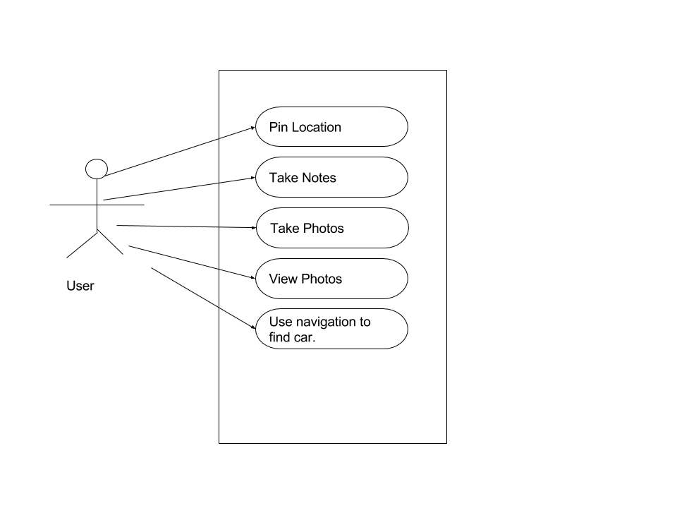

* 1. **User characteristics**

A typical personal user is expected to be able to:

* Pin their current location.
* Take and view photos.
* Use navigation to return to their pined location.

**2.4 Constraints**

**2.4.1 Operating Systems**

The average usage for this mobile application will be for smart phones and tablets that support Android operating systems. This application will be developed for the latest Apple operating system, IOS 9.3. Older versions of the minimum requirement will not be supported.

**2.4.2 Connections**

This application will require at least a 1GB connection with a suggested data connectivity of 3GB or more. This application will support WIFI and will be GPS enabled.

**2.4.3 Platforms**

This application will be written using a single platform, but with a multiplatform concept in plan for the future near future, for the purpose of supporting future platforms.

**2.4.4 Content Creation**

A basic profile will be required to be made by the user. After which the user will not be required to provide any more information, and all data input will be retrieved automatically.

**2.4.5 Accessibility**

The application will comply to the accessibility standards as outlined by The World Wide Web Consortium (w3c) <http://www.w3.org/standards/webdesign/accessibility>

**2.5 Assumptions and Dependencies**

This application will depend on:

* IOS 9.3
* JavaScript
* PHP 5.4+
* MySQL 5.5
* HTML 5 (HTML, CSS, Javascript, XML, JSON)

**3.1 Performance Requirements**

* The application will load within 5 seconds on an android based phone.
* Examples of the application functions include pressing buttons, keyboard input, loading a live feed, GPS location services, and using the sidebar.
* Non local functions such as login, live feed, location services and search are limited by the server and mobile device’s connection. A stable connection is recommended to provide a more efficient response time.
* **3.3 Design Constraints**
* The graphics will be designed and scaled for Android smartphone devices. Graphics will adjust according to screen sizes.

**3.4 Software system attributes**

* The app must maintain reliability, availability and maintainability.
* With reliability, the system must give the right search result when queried for intended profiles. System availability will be succeeded when the app is available 100% of the time but must be available at least 98% of the time. The application should be easy to maintain and expand upon future changes and new implementations.

**3.5 Security Requirements**

* The security of the accounts on the application must be secured as unauthorized users cannot access the features of the application without supplying a correct username and corresponding password. A user must be notified of an incorrect login session when either username or password authentication fails.